# **Task-4 Project Phase 2**

Installed Docker and Docker Compose

Docker-Compose Installed

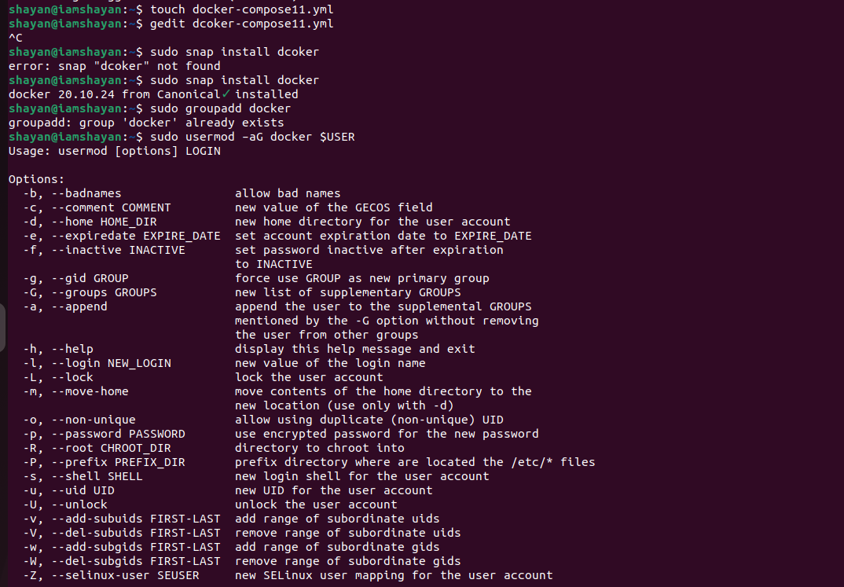

Files

